 | Testing and Training Center of Farm Machinery  Department of Farm Machinery and Power Engineering  College of Agricultural Engineering and Technology  Junagadh Agricultural University  JUNAGADH – 362 001 (GUJARAT) | 
P | Phone : (0285) 2672080-90, Ext. 390 & 484; Fax : (0285) 2671018

SPECIFICATION SHEET OF BLADE HARROW (TRACTOR DRAWN)

1.0 | General |  | :
1.0 | Name of machine |  | :
1.0 | Name and address of manufacturer |  | :
1.0 | Name and address of applicant |  | :
1.0 | Selling price in India |  | :
2.1 | Constructional details:
2.1 | a) | Name | :
2.1 | b) | Type | :
2.1 | c) | Make | :
2.1 | d) | Serial Number | :
2.1 | e) | Model | :
2.1 | f) | Year of manufacture | :
2.1 | h) | Name and address of manufacture | :
2.1 | i) | Source of power | :
2.1 | j) | Recommended power of tractor, if tractor operated | :
2.2 | Frame:
2.2 | a) | Constructional details | :
2.2 | b) | Dimensions (mm) | :
2.3 | Tyne:
2.3 | a) | No of tynes | :
2.3 | b) | Arrangement on main frame | :
2.3 | c) | Type | :
2.3 | d) | Material | :
2.3 | e) | Size (mm) | :
2.3 | f) | Length (mm)
2.3 |  | - curved | :
2.3 |  | - projected | :
2.3 | g) | Width (mm)
2.3 | h) | No. and size of hole on each tyne for fixing blade to it | :
2.3 | i) | Center to center distance between the holes (mm) | :
2.3 | j) | No. and size of bolts for tightening blade to the tyne | :
2.3 | k) | Method of fixing | :
2.3 | l) | Provision for height adjustments | :
2.4 | Blade :
2.4 | a) | Material and size (mm) | :
2.4 | b) | Beveled edge thickness (mm) | :
2.4 | c) | Width of beveled edge (mm) | :
2.4 | d) | No. and size (mm) of holes on the blade | :
2.4 | e) | No., size and types of bolts for fitting blade (mm) | :
 | f) | Method of fixing
2.5 | Hitch Pyramid:
2.5 | a) | Constructional details | :
 | b) | Material | :
 | c) | Size (mm) | :

Sr. | Dimension | Description (Refer Fig.) | Dimension in mm
Upper Hitch attachments
1 | d₁ | Diameter of hitch pin hole
2 | b’₁ | Width between inner faces of yoke
3 | b’₂ | Width between outer faces of yoke
Lower hitch points
4 | D₂ | Dia of hitch pin
5 | b’₃ | Linch pin hole distance
6 | l | Lower hitch point span
Other dimensions
 | Diameter of linch pin hole
7 | d | For upper hitch pin
8 |  | For lower hitch pin
9 | h | Mast height
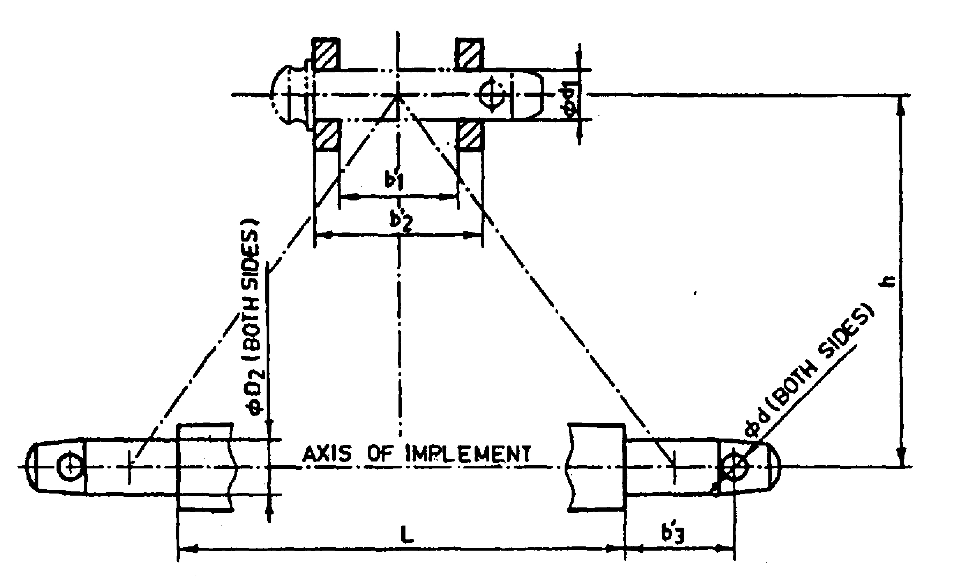
Fig. : Implement Hitch Attachment

4.3 | Material of construction:
4.3 | Name of components |  | Material used | Size (mm)
4.3 | a) | Main frame
4.3 | b) | Tyne
4.3 | c) | Shovel
4.3 | d) | Hitch pyramid

4.4 | Overall dimensions (mm):
4.4 | a) | Length | :
4.4 | b) | Width | :
4.4 | c) | Height | :
4.5 | Total mass (kg) |  | :
4.6 | Color of implement |  | :

Place:
Date:
Signature : ________________________

Name : ________________________

Designation: ________________________

